Instagram

Topic | DiscoverEU application round
Post | Are you 18 years old and ready to step out of your comfort zone? 👣  Apply for a #DiscoverEU travel pass and start exploring more than 3️⃣0️⃣ countries in the EU and beyond!  The next application round opens from 📅 15-29 March.  To be eligible to apply, you must be  ✅ born on or between 1 July 2004 – 30 June 2005  ✅ a legal resident of an EU 🇪🇺 Member State or Iceland 🇮🇸, Liechtenstein 🇱🇮, North Macedonia 🇲🇰, Norway 🇳🇴, Serbia 🇷🇸 or Türkiye 🇹🇷  ✅ ready for the adventure of a lifetime 🚀  If that sounds like you, click the link in bio to learn more.  --  #EuropeanYouth #ErasmusPlus #Europe #EuropeanUnion #EU #ExpandYourComfortZone #travelling #eurotravel #wanderlust #travelphotography #travelblog #health #healthylifestyle
Visual | 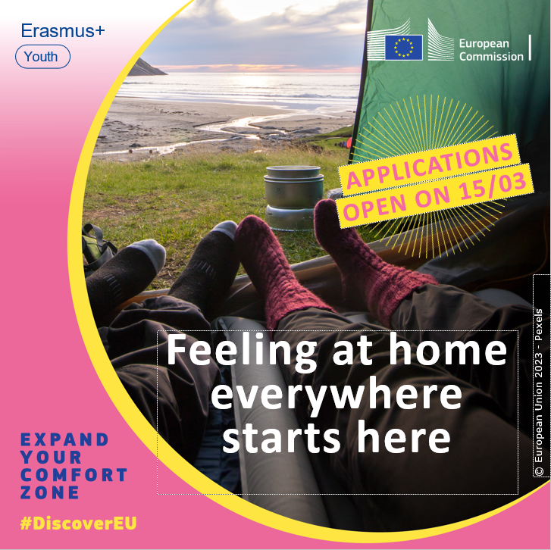
Tags | @european_youth_eu

Facebook
Topic | DiscoverEU application round
Post | Are you 18 years old and ready to step out of your comfort zone? 👣  Apply for a #DiscoverEU travel pass and start exploring more than 3️⃣0️⃣ countries in the EU and beyond!  The next application round opens from 📅 15-29 March.  To be eligible to apply, you must be  ✅ born on or between 1 July 2004 – 30 June 2005  ✅ a legal resident of an EU 🇪🇺 Member State or Iceland 🇮🇸, Liechtenstein 🇱🇮, North Macedonia 🇲🇰, Norway 🇳🇴, Serbia 🇷🇸 or Türkiye 🇹🇷  ✅ ready for the adventure of a lifetime 🚀  If that sounds like you, learn more here ➡ https://europa.eu/youth/discovereu_en
Visual

Twitter
Topic | DiscoverEU application round
Tweet | Have you heard?  The next application round of #DiscoverEU will open from 📅 15-29 March!  If you’re:  ✅ born from 1 July 2004 – 30 June 2005  ✅ a legal resident of 🇪🇺 or 🇮🇸 🇱🇮 🇲🇰 🇳🇴 🇷🇸 🇹🇷  Be sure to mark your calendar! Learn more here ➡ https://europa.eu/youth/discovereu_en
Visual | 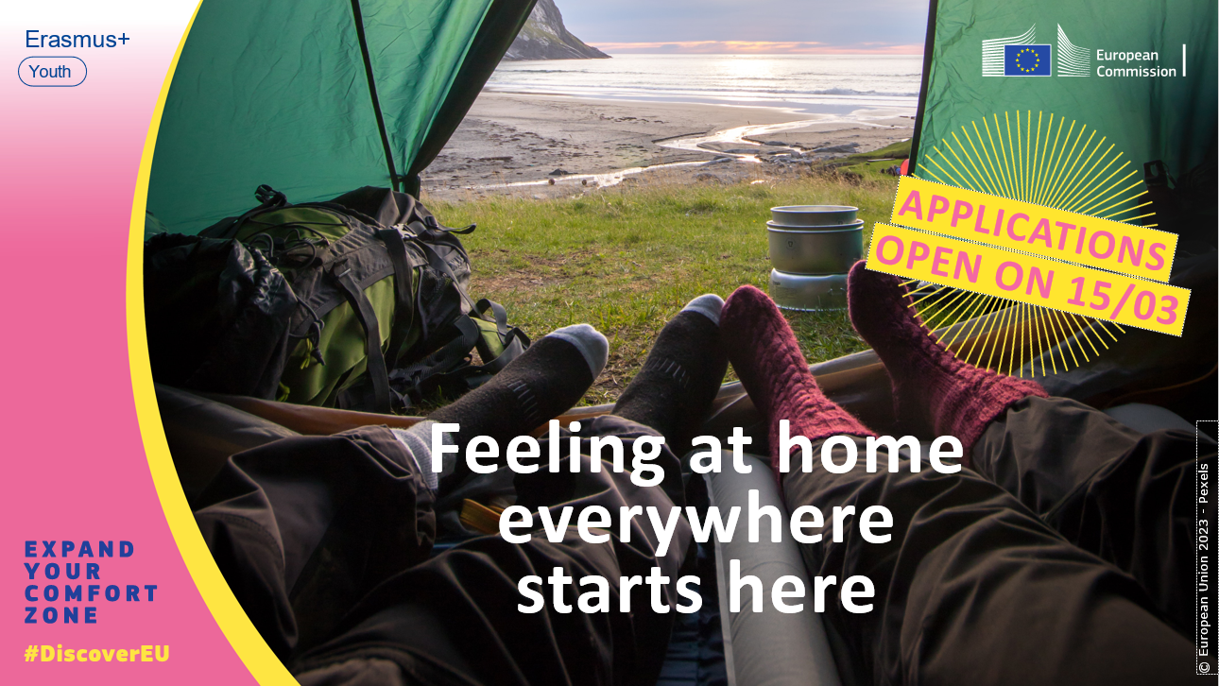
Tags | @EuropeanYouthEU

