Instagram

Topic | DiscoverEU application round
Post | 🌟Ready to embark on an adventure? Are you 18 years old and eager to step out of your comfort zone? 👣  📆 Save the date! The next application round opens from 16 – 30 April. 🚀  Apply for your #DiscoverEU travel pass and unlock this incredible opportunity to explore the European Union! 🌍  To be eligible to apply, you need to:  ✅ Be born between 1 July 2005 and 30 June 2006  ✅ Be a legal resident of an EU 🇪🇺 Member State or one of the following countries: Iceland 🇮🇸, Liechtenstein 🇱🇮, North Macedonia 🇲🇰, Norway 🇳🇴, Serbia 🇷🇸, or Türkiye 🇹🇷.  ✅ Be ready to embrace the adventure of a lifetime!  If you're up for the challenge, click the link in our bio 🔗 to learn more. 🌐  --  #EuropeanYouth #ErasmusPlus #Europe #EuropeanUnion #EU #ExpandYourComfortZone #travelling #eurotravel #wanderlust #travelphotography #travelblog #health #healthylifestyle
Visual | 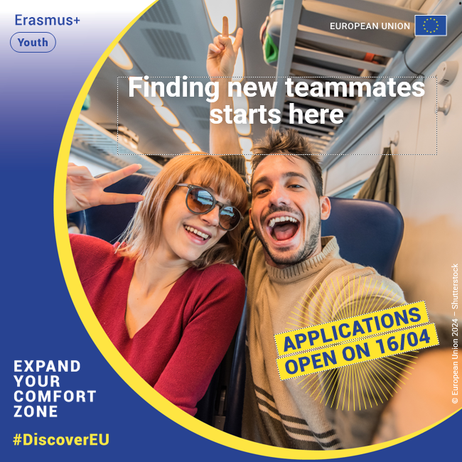
Tags | @european_youth_eu

Facebook
Topic | DiscoverEU application round
Post | 🌟Ready to embark on an adventure? Are you 18 years old and eager to step out of your comfort zone? 👣  📆 Save the date! The next application round opens from 16 – 30 April. 🚀  Apply for your #DiscoverEU travel pass and unlock this incredible opportunity to explore the European Union! 🌍  To be eligible to apply, you need to:  ✅ Be born between 1 July 2005 and 30 June 2006  ✅ Be a legal resident of an EU 🇪🇺 Member State or one of the following countries: Iceland 🇮🇸, Liechtenstein 🇱🇮, North Macedonia 🇲🇰, Norway 🇳🇴, Serbia 🇷🇸, or Türkiye 🇹🇷.  ✅ Be ready to embrace the adventure of a lifetime!  If you're up for the challenge, learn more 🔗 https://europa.eu/youth/discovereu_en
Visual

Twitter
Topic | DiscoverEU application round
Tweet | Have you heard the news?  The next application round of #DiscoverEU will open from 📅 16-30 April!  If you’re:  ✅ born 1 Jul 2005 - 30 June 2006  ✅ a legal resident of 🇪🇺 or 🇮🇸 🇱🇮 🇲🇰 🇳🇴 🇷🇸 🇹🇷  Be sure to mark your calendar! Learn more here ➡ https://europa.eu/youth/discovereu_en
Visual
Tags | @EuropeanYouthEU

