Instagram

Topic | DiscoverEU application round
Post | 18-year-olds – we’re coming your way! How about exploring our stunning continent, levelling up your skills AND making new friends? We hope you’re ready for an unforgettable journey because we’re delivering! 🌍✨  With the #DiscoverEU travel pass, you can uncover the wonders of Europe like never before 🚆  📅 Prepare for the new application round: open between 2 - 16 April!  To apply, make sure you:  ✅ were born between 1 July 2006 and 30 June 2007  ✅ are a legal resident of an EU 🇪🇺 Member State or one of these countries: Iceland 🇮🇸, Liechtenstein 🇱🇮, North Macedonia 🇲🇰, Norway 🇳🇴, Serbia 🇷🇸, or Türkiye 🇹🇷.  ✅ are ready for a once in a lifetime experience!  Click on the link in our bio 🔗 for all the details and let the adventure begin! 🚀  --  #EuropeanYouth #ErasmusPlus #Europe #EuropeanUnion #EU #ExpandYourComfortZone #Travelling #EuroTravel #Wanderlust #TravelPhotography #TravelBlog #Health #HealthyLifestyle  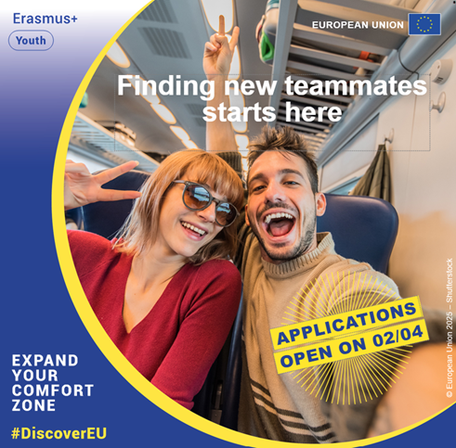
Tags | @european_youth_eu

Facebook
Topic | DiscoverEU application round
Post | You can learn so much by exploring Europe, and #DiscoverEU makes it possible! 🇪🇺 🚆  18-year-olds who are ready for the adventure of a lifetime get the chance to win a #DiscoverEU travel pass to experience our stunning continent while levelling up their skills and making new friends. 🌍✨  📅 New application round from 2 – 16 April. Eligible people are:  ✅ born between July 1, 2006, and June 30, 2007  ✅ a legal resident of an EU Member State or one of the following countries: Iceland 🇮🇸, Liechtenstein 🇱🇮, North Macedonia 🇲🇰, Norway 🇳🇴, Serbia 🇷🇸, or Türkiye 🇹🇷  ✅ prepared for a wonderful journey  Share this opportunity with someone and follow the link to know more: https://europa.eu/!Ny43uF  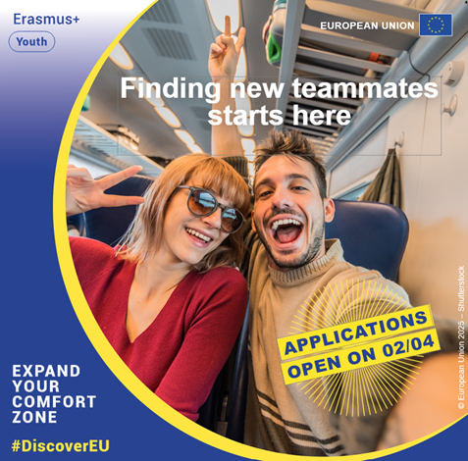

X
Topic | DiscoverEU application round
Tweet | Dreaming of exploring Europe?🌍  📅 The new #DiscoverEU application round will be open from 2-16 April  If you're:  ✅born between 1 July 2006, and 30 June 2007  ✅legal resident of 🇪🇺 or 🇮🇸 🇱🇮 🇲🇰 🇳🇴 🇷🇸 🇹🇷  🚀Get ready and let the adventure begin!  Learn more here🔗 https://europa.eu/youth/discovereu_en  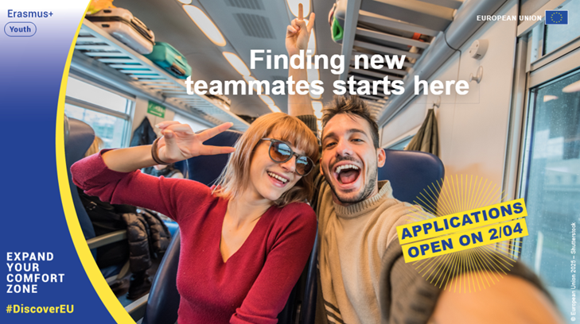
Tags | @EuropeanYouthEU

